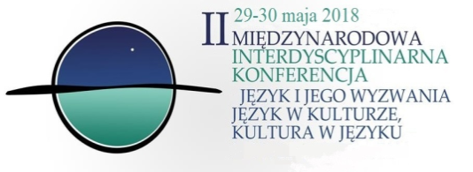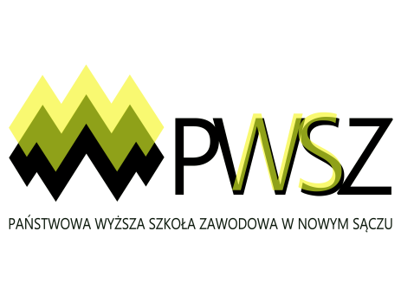

Institute of Foreign Languages

State University of Applied Sciences
in Nowy Sącz

is pleased to announce

2nd INTERNATIONAL INTERDISCIPLINARY CONFERENCE

on

Challenges in Language:
Language in Culture and Culture in Language

Nowy Sącz, Poland
29-30 May, 2018

CONFERENCE THEME

Each person has an innate predisposition to acquire and speak languages. We use it every day – in casual acts of communication and in formal contexts. Languages accompany us and our cultures, they live with us, develop with us and change under our influence. The aim of the conference is to address new perspectives on language within culture and culture reflected in language, especially in the context of the ongoing process of globalization.

We welcome interdisciplinary contributions (both papers and poster presentations) from the fields of:
- linguistics,
- language teaching and learning,
- literature,
- philosophy,
- psychology and pedagogy,
- history,
- social and cultural studies,
- other related field.
We also welcome presentations by students in our student panel (please fill in the Student Registration Form).
Time allowed for paper presentation is 20 minutes followed by 10-minute time for its discussion.
SCIENTIFIC COMMITTEE
prof. dr hab. Mariola Wierzbicka
dr hab. prof. Zdzisława Zacłona, prof. PWSZ
dr hab. Anna Walczuk, prof. PWSZ
dr hab. Lesława Korenowska​, prof. PWSZ​

​ REGISTRATION & ABSTRACT SUBMISSION
To register, please return the completed registration form by 9th April 2018. The registration fee, which is 350 PLN (approx. 70 Euro depending on the exchange rates), covers organization costs, conference materials, conference dinner, and a monographic publication. Accommodation is not included in the fee, however, we will provide you with contact information to hotels and hostels in the area.
Publication fee (without participation in the conference) is 200 PLN.
We accept proposals in English, German, Russian and Polish. Abstracts should be 200-250 words long and should be submitted, together with a registration form, by e-mail to konferencja_ijo@pwsz-ns.edu.pl by 9th April 2018. The proposals should include the title, name, affiliation, e-mail address. Notifications of acceptance will be sent by 16th April 2018.
Conference proceedings will be reviewed and published as a monograph by the end of 2018.
We do not offer assistance in obtaining visas.

PAYMENT AND BANK ACCOUNT DETAILS
The fee must be paid not later than 15th May 2018 to our conference account.
Please make sure that the transfer is made in Polish zloty (PLN) – it should be made to
Bank account:
PKO SA
Nowy Sącz
ul. Jagiellońska 26
​
84 1240 4748 1111 0010 4341 0034
Swift code: PKO PPLPW
Address:
Panstwowa Wyzsza Szkola Zawodowa
Staszica 1
33-300 Nowy Sącz
Title must include konferencja.ijo_your.name
Please visit our website: https://konferencja2018ns.weebly.com/

FURTHER INFORMATION
If you have further questions concerning the conference please send them to konferencja_ijo@pwsz-ns.edu.pl
With best regards,
Conference Organisers
doc. dr Elżbieta Stanisz
dr Monika Madej-Cetnarowska
dr Katarzyna Jasiewicz
dr Monika Zięba-Plebankiewicz
dr Jarosław Giza
dr Grzegorz Ziętala
dr Marta Kurzeja
dr Rachela Pazdan
dr Paulina Wójcikowska-Wantuch

